NATIONAL COMMUNICATIONS AUTHORITY

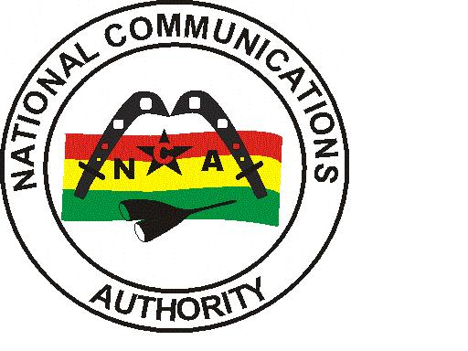

**GLO 3G COVERAGE REPORT – GREATER ACCRA REGION**

|  |
| --- |
| Test conducted | April 2022 |

**Contents**

List of Figures 1

List of Tables 1

1.0 EXECUTIVE SUMMARY 2

1.1 METHODOLOGY 2

1.2 FINDINGS AND ANALYSIS 3

1.2.1 Test Locations 3

1.2.2 Coverage Status 4

1.2.3 3G Coverage Plot 6

1.2.4 RSCP Sampling Distribution 13

1.3 CONCLUSION 14

## List of Figures

Figure 1. 3G Coverage Plot – Abokobi 6

Figure 3. 3G Coverage Plot – Adenta 7

Figure 4. 3G Coverage Plot – Amasaman 8

Figure 5. 3G Coverage Plot – Dansoman 8

Figure 6. 3G Coverage Plot – Dodowa 9

Figure 7. 3G Coverage Plot – Kokomlele 9

Figure 8. 3G Coverage Plot – Kpone 12

Figure 9. 3G Coverage Plot – La 12

Figure 10. 3G Coverage Plot – Madina 12

Figure 11. 3G Coverage Plot – Nungua 12

Figure 12. 3G Coverage Plot – Prampram 12

Figure 13. 3G Coverage Plot – Sege 12

Figure 14. 3G Coverage Plot – Sowutuom 12

Figure 15. 3G Coverage Plot – Tema 12

Figure 16. 3G Coverage Samples Plot 13

## List of Tables

Table 1: Signal Strength Range 2

Table 2: 3G Coverage Assessment Schedule and Test Locations 3

Table 3: Coverage Status and Average Signal strength for each test location 4

## 1.0 EXECUTIVE SUMMARY

Clause 6.4 of Annex A of the 3G Licence directs the Licensee to roll-out 3G deployment across all Metropolitan, Municipal and District capitals of the country within five (5) years after the effective date of the Licence. In order to monitor and ensure compliance of coverage obligations, a 3G Coverage verification campaign was carried out from 11th March to 9th April 2022 in Fourteen (14) District Capitals in the GREATER ACCRA Region. The findings of the audit exercise revealed GLO’s 3G coverage presence in twelve (12) out of all fourteen (14) tested district capitals; with coverage improvement required in some communities.

## 1.1 METHODOLOGY

The methodology used in this exercise relied on field tests performed using NEMO INVEX II for data collection.

Measurement samples were collected in idle 3G-locked drive-test mode along pre-defined route within each district capital in the Greater Accra Region.

Network coverage assessment was made by measuring the downlink signal levels, CPICH RSCP (Common Pilot Channel Received Signal Code Power) for WCDMA/UMTS services.

The main indicators used for this exercise was based on parameters below:

* Signal Strength (dBm)
* Coverage Status

Generally, the signal strength as seen in NEMO WIND CATCHER is shown below:

Table 1: Signal Strength Range

|  |  |  |  |  |
| --- | --- | --- | --- | --- |
| Radio Access Technology | Signal Strength Range (dBm) | | | |
| WCDMA (3G) | -105>RSCP | –105≤ RSCP < -95 | –95≤ RSCP< –85 | –85 ≤RSCP < –20 |
| Rating | Non-existent | Poor | Fair | Good |

The essence of the idle 3G-locked mode of coverage sample collection was to obtain on the average a signal strength measurement which is representative of the coverage situation in each of the district capital that was driven.

A “**Not Covered**” coverage status is rated on the basis that either a “No WCDMA signal” was detected by the measurement system or the average RSCP level obtained was less than -105 dBm as stipulated under Section 1.5 of Annex A of the 3G Licence.

A “**Not Maintained**” coverage status is rated on the basis that even though a “No WCDMA signal” was detected or RSCP level obtained was less than -105 dBm, an independent analysis by the Authority confirmed that coverage had existed but was not maintained at the period of the drive.

## 1.2 FINDINGS AND ANALYSIS

## 1.2.1 Test Locations

The 3G monitoring exercise was started in the Greater Accra Region on 11th March 2022 at 10:22am and ended on 9th April 2022 at 11:20am.

The test was conducted on perceived busy hour periods depending on the social and business activities and subscriber behaviour in the Region. Test was carried out every day for four (4) days in each District Capital.

Table 2 below indicates detailed locations and times at which the tests were conducted.

Table 2: 3G Coverage Assessment Schedule and Test Locations

| CLUSTER | DATE | TIME | DRIVEN ROUTE |
| --- | --- | --- | --- |
| A | 11/03/2022 | 10:22 am - 01:22 pm | Adenta |
| B | 11/03/2022 | 05:36 pm - 07:37 pm | Abokobi |
| C | 12/03/2022 | 07:58 am - 11:05 am | Adenta |
| D | 12/03/2022 | 05:58 pm - 07:59 pm | Abokobi |
| E | 13/03/2022 | 07:55 am - 10:58 am | Adenta |
| F | 13/03/2022 | 02:38 pm - 04:38 pm | Abokobi |
| G | 14/03/2022 | 02:21 pm - 03:33 pm | La |
| H | 14/03/2022 | 12:00 pm - 03:03 pm | Adenta |
| I | 14/03/2022 | 03:22 pm - 05:28 pm | Abokobi |
| J | 15/03/2022 | 10:19 am - 12:39 pm | Nungua |
| K | 15/03/2022 | 10:30 am - 12:27 pm | Amasaman |
| L | 15/03/2022 | 04:02 pm - 05:35 pm | La |
| M | 16/03/2022 | 08:13 am - 09:39 am | La |
| N | 16/03/2022 | 09:08 am - 11:46 am | Amasaman |
| O | 16/03/2022 | 02:44 pm - 05:09 pm | Nungua |
| P | 17/03/2022 | 06:43 am - 08:22 am | La |
| Q | 17/03/2022 | 08:58 am - 11:21 am | Amasaman |
| R | 17/03/2022 | 04:07 pm - 05:56 pm | Nungua |
| S | 18/03/2022 | 09:16 am - 11:44 am | Amasaman |
| T | 18/03/2022 | 09:54 am - 12:35 pm | Nungua |
| U | 21/03/2022 | 10:26 am - 11:59 am | Tema |
| V | 22/03/2022 | 09:37 am - 12:13 pm | Dansoman |
| W | 22/03/2022 | 12:17 pm - 01:40 pm | Sege |
| X | 22/03/2022 | 04:03 pm - 05:29 pm | Tema |
| Y | 22/03/2022 | 04:08 pm - 06:59 pm | Sowutuom |
| Z | 23/03/2022 | 08:00 am - 11:01 am | Dansoman |
| AA | 23/03/2022 | 01:27 pm - 02:48 pm | Sege |
| AB | 23/03/2022 | 02:43 pm - 05:43 pm | Sowutuom |
| AC | 23/03/2022 | 05:17 pm - 06:31 pm | Tema |
| AD | 24/03/2022 | 07:07 am - 10:19 am | Dansoman |
| AE | 24/03/2022 | 10:00 am - 11:13 am | Sege |
| AF | 24/03/2022 | 11:30 am - 10:57 pm | Sowutuom |
| AG | 24/03/2022 | 02:42 pm - 04:04 pm | Tema |
| AH | 25/03/2022 | 08:07 am - 11:08 am | Dansoman |
| AI | 25/03/2022 | 02:25 pm - 03:30 pm | Sege |
| AJ | 25/03/2022 | 02:52 pm - 06:05 pm | Sowutuom |
| AK | 28/03/2022 | 09:22 am - 02:45 pm | Madina |
| AL | 28/03/2022 | 04:51 pm - 06:30 pm | Dodowa |
| AM | 29/03/2022 | 08:18 am - 01:38 pm | Madina |
| AN | 29/03/2022 | 02:23 pm - 03:45 pm | Dodowa |
| AO | 30/03/2022 | 09:12 am - 02:50 pm | Madina |
| AP | 30/03/2022 | 01:04 pm - 02:56 pm | Kpone |
| AQ | 30/03/2022 | 05:07 pm - 06:32 pm | Dodowa |
| AR | 31/03/2022 | 09:27 am - 02:57 pm | Madina |
| AS | 31/03/2022 | 01:38 pm - 03:18 pm | Kpone |
| AT | 31/03/2022 | 05:57 pm - 07:16 pm | Dodowa |
| AU | 01/04/2022 | 08:51 am - 10:41 am | Prampram |
| AV | 01/04/2022 | 03:05 pm - 04:42 pm | Kpone |
| AW | 02/04/2022 | 08:15 am - 10:02 am | Prampram |
| AX | 02/04/2022 | 11:59 am - 01:53 pm | Kpone |
| AY | 03/04/2022 | 06:29 am - 08:07 am | Prampram |
| AZ | 04/04/2022 | 08:10 am - 10:07 am | Prampram |
| BA | 06/04/2022 | 09:21 am - 11:31 am | Kokomlemle |
| BB | 07/04/2022 | 09:14 am - 11:23 am | Kokomlemle |
| BC | 08/04/2022 | 09:03 am - 11:23 am | Kokomlemle |
| BD | 09/04/2022 | 08:48 am - 11:20 am | Kokomlemle |

## 1.2.2 Coverage Status

Table 3: Coverage Status and Average Signal strength for each test location

| No. | District Capital | Average RSCP (≥ -105dBm) | | | | Coverage Status |
| --- | --- | --- | --- | --- | --- | --- |
| Day 1 | Day 2 | Day 3 | Day 4 |
| 1 | Abokobi | -94.05 | No 3G Cov. | -93.14 | -94.71 | Fair network coverage in Abokobi. However, major network coverage improvement is required around Abokobi Royal Porter’s City Church, the Hillview Guest Center and the Abokobi Presbyterian Church. |
| 2 | Adenta | -78.32 | -77.59 | -76.92 | -77.90 | Good network coverage in Adenta. However, major network coverage improvement is needed in areas around Adenta municipal assembly and around calvary Baptist church close to vanilla street. |
| 3 | Amasaman | -81.20 | -82.81 | -80.83 | -82.15 | Good network coverage in Amasaman. Major network coverage improvement is needed at the Pokuase agric bungalows and Amasaman SDA Church. |
| 4 | Dansoman | -77.37 | -79.00 | -75.64 | -78.40 | Good network coverage in Dansoman. Major network coverage improvement is required in and around the Dansoman SSNIT flats. |
| 5 | Dodowa | -92.48 | -94.13 | -94.31 | -93.70 | Fair network coverage in Dodowa. However, major network improvements needed within the entire commuinity. |
| 6 | Kokomlele | -71.27 | -70.69 | -72.38 | -70.56 | Good network coverage in Kokomlele. |
| 7 | Kpone | -87.16 | -87.18 | No Data | -84.89 | Good network coverage in Kpone. Major network coverage improvement is required around the Sunon-asogli power limited, Kpone beach resort and the Bethel presbyterian church. |
| 8 | La | -76.06 | -77.48 | -74.83 | -75.75 | Good network coverage in La. However major network improvements is needed around Fraga oil station, Club Suku-suku (Annex), La Dade-Kotopon municipal assembly and the shell filling station – La Beach. |
| 9 | Madina | -81.42 | -81.85 | -81.05 | -80.86 | Good network coverage in Madina. Major network coverage improvement is needed around Okai Road and Adenta west. |
| 10 | Nungua | -82.38 | -89.70 | -76.44 | -94.00 | Good network coverage in Nungua. However major network improvement is needed within the entire community. |
| 11 | Prampram | **-107.52** | **-107.12** | **-107.01** | **-106.25** | Non-existent network coverage in Prampram. The entire district needs network coverage improvement. |
| 12 | Sege | **-113.85** | **No 3G Coverage** | **-110.82** | **-113.85** | Non- existent network coverage in Sege. The entire district needs network coverage improvement. |
| 13 | Sowutuom | -73.36 | -73.57 | -74.26 | -74.26 | Good network coverage in Sowutuom. Major network coverage improvement is required around the Envaserv research consult and Ryam gift hub |
| 14 | Tema | -76.36 | -75.63 | -76.32 | -75.16 | Good network coverage in Tema. However, minor network improvement needed around Telesol and Access bank. |

## 1.2.3 3G Coverage Plot

Figure . 3G Coverage Plot – Abokobi

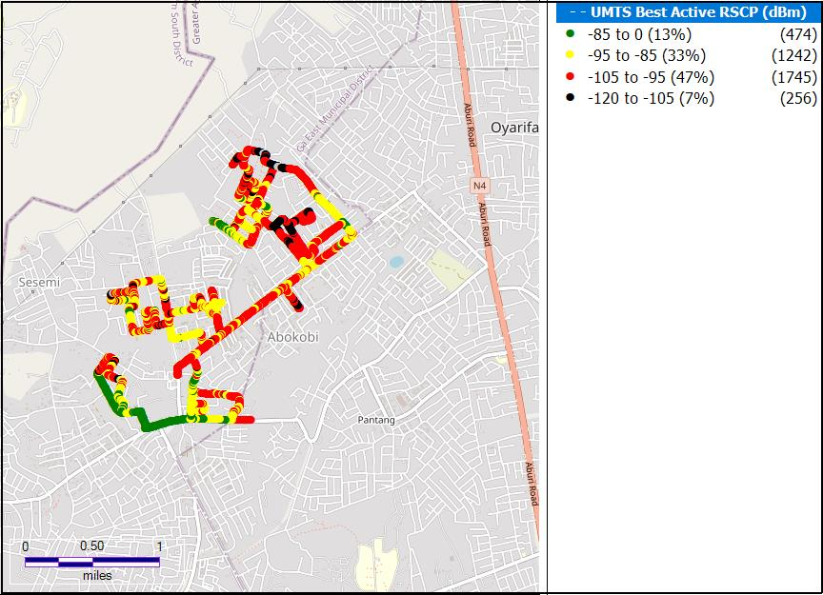

**Remarks:** Fair network coverage in Abokobi. However, major network coverage improvement is required around Abokobi Royal Porter’s City Church, the Hillview Guest Center and the Abokobi Presbyterian Church.

Figure 2. 3G Coverage Plot – Adenta

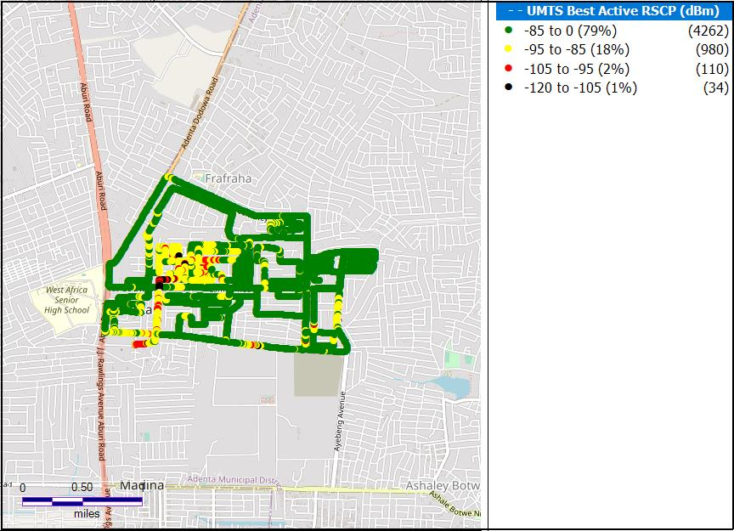

**Remarks:** Good Network Coverage in Adenta. However, major network coverage improvement is needed in areas around Adenta municipal assembly and around calvary Baptist church close to vanilla street.

Figure . 3G Coverage Plot – Amasaman

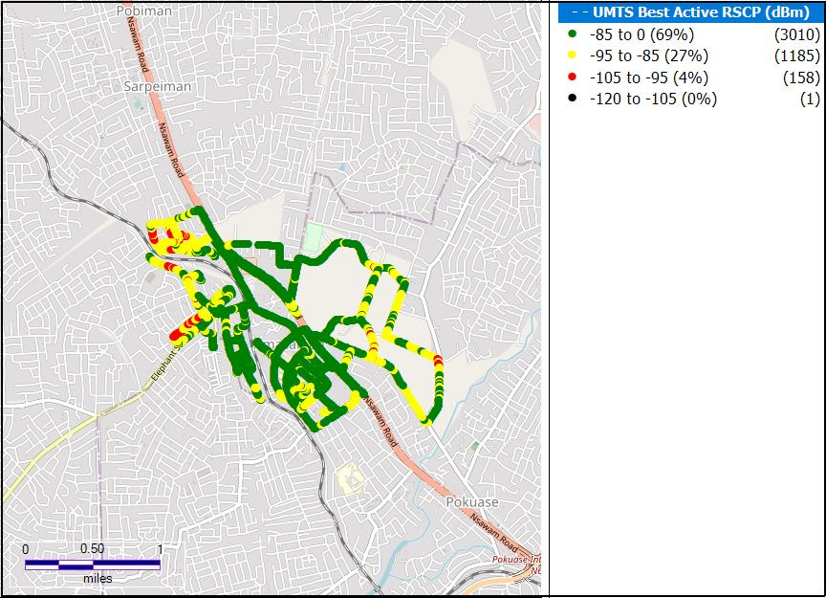

**Remarks:** Good network coverage in Amasaman. Major network coverage improvement is needed at the Pokuase agric bungalows and Amasaman SDA Church.

Figure . 3G Coverage Plot – Dansoman

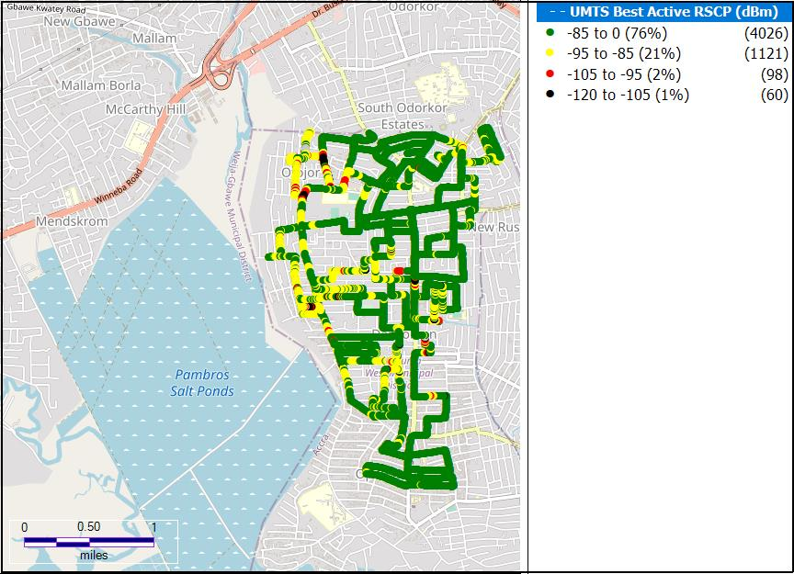

**Remarks:** Good Network Coverage in Dansoman. Major network coverage improvement is required in and around the Dansoman SSNIT flats.

Figure . 3G Coverage Plot – Madina

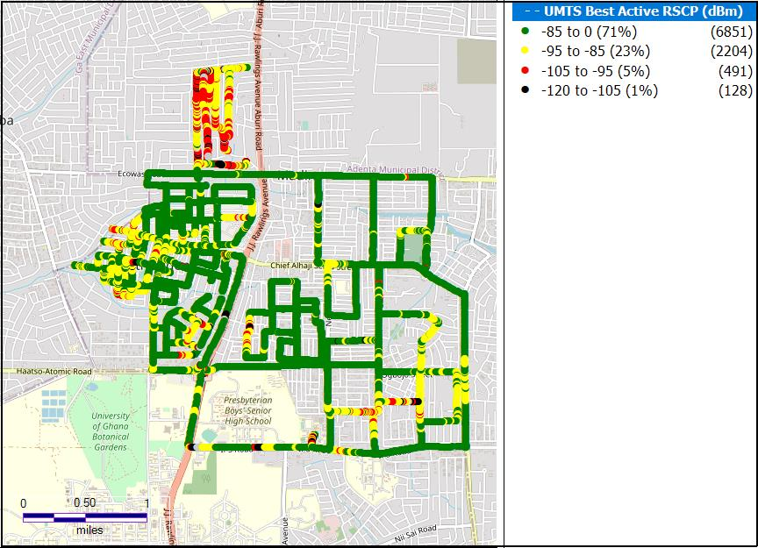

**Remarks:** Good network coverage in Madina. Major network coverage improvement is needed around Okai Road and Adenta west.

**Figure 6. 3G Coverage Plot – Kokomlele**

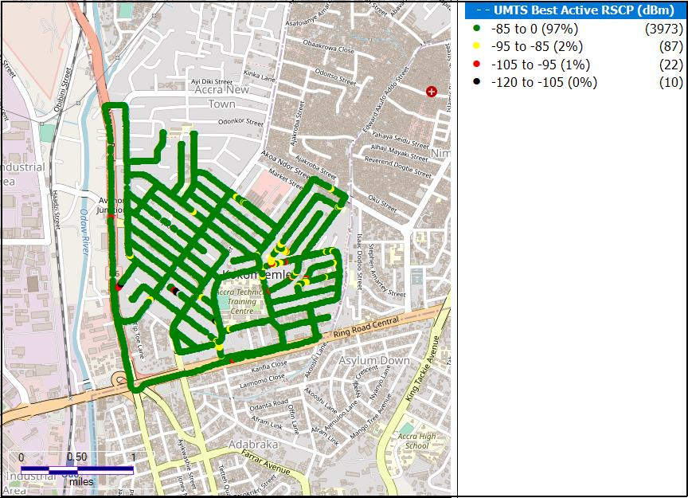

**Remarks:** Good Network Coverage in Kokomlele.

**Figure 7. 3G Coverage Plot – Kpone**

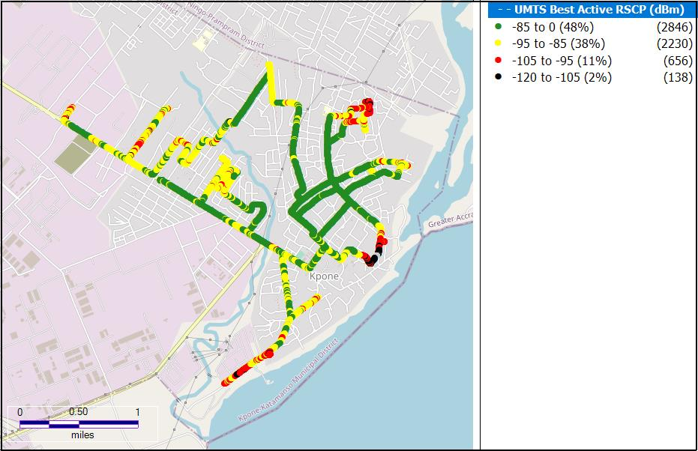

**Remarks:** Good network coverage in Kpone. Major network coverage improvement is required around the Sunon-asogli power limited ,Kpone beach resort and the Bethel presbyterian church.

Figure . 3G Coverage Plot – Dodowa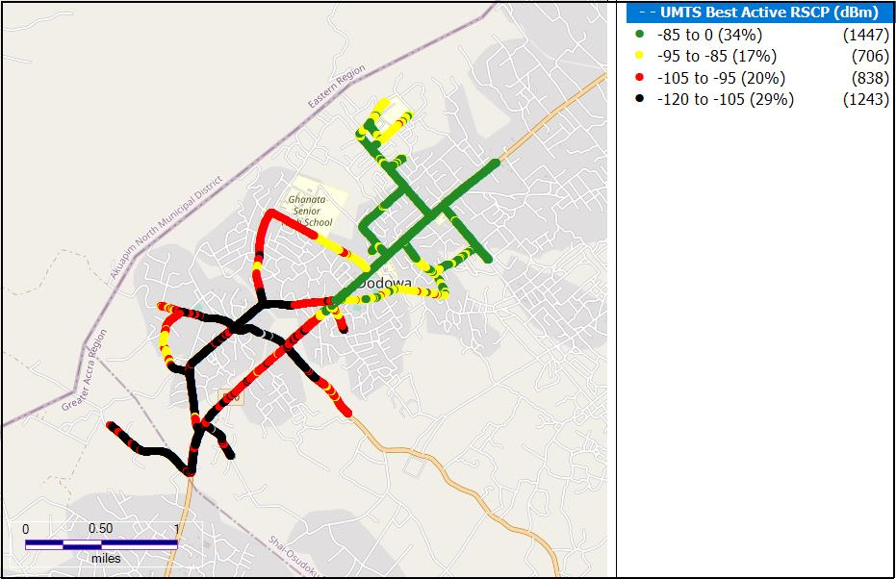

**Remarks:** Fair network coverage in Dodowa. However, major network improvements needed within the entire commuinity.

**Figure 9. 3G Coverage Plot - La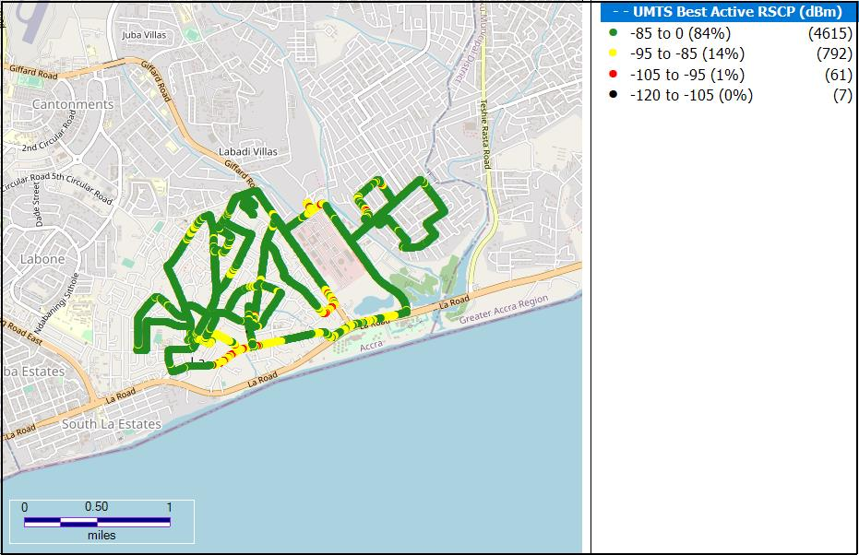Remarks:** Good network coverage in La. However major network improvements is needed around Fraga oil station, Club Suku-suku (Annex), La Dade-Kotopon municipal assembly and the shell filling station – La Beach.

**Figure 10. 3G Coverage Plot – Nungua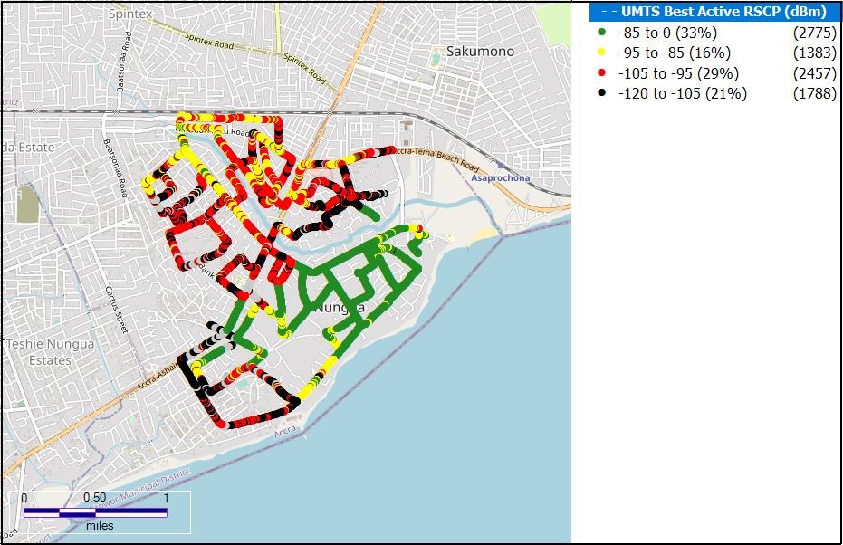Remarks:** Good network coverage in Nungua. However major network improvement is needed within the entire community.

**Figure 11. 3G Coverage Plot – Prampram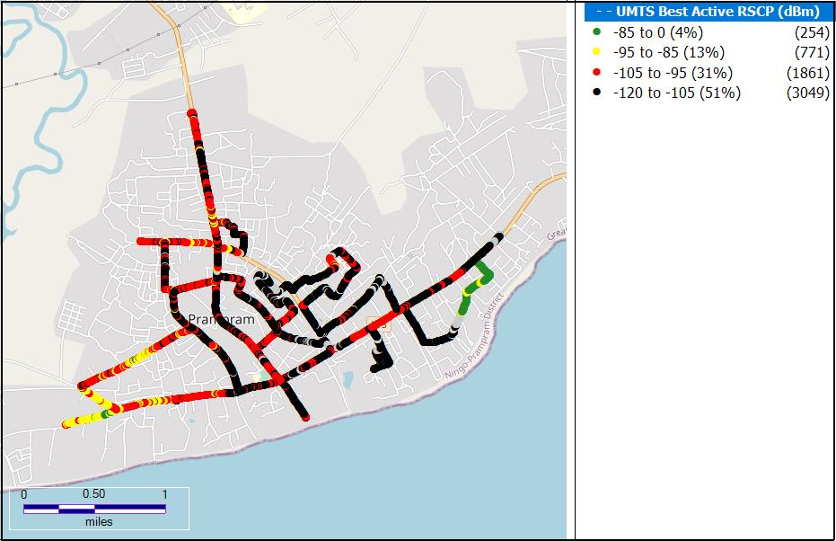Remarks:** Non-existent network coverage in Prampram. The entire district needs network coverage improvement.

**Figure 12. 3G Coverage Plot – Sege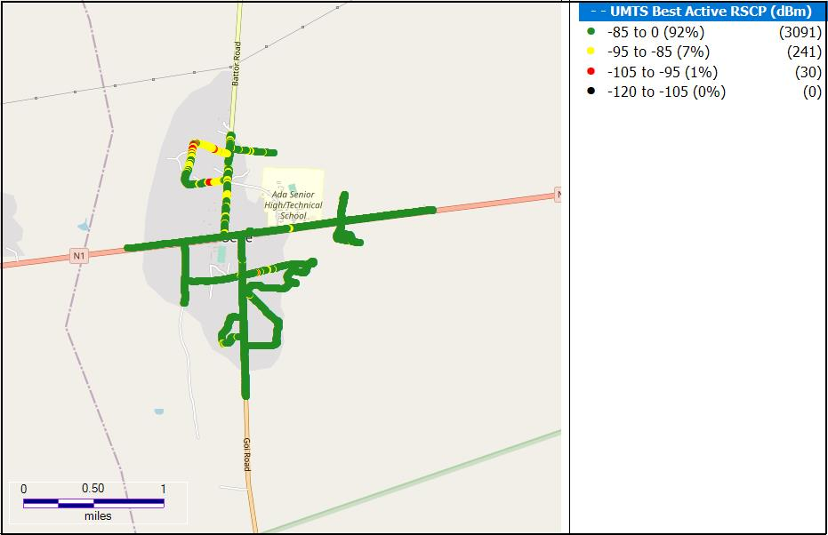Remarks:** Non- existent network coverage in Sege. The entire district needs network coverage improvement.

**Figure 13. 3G Coverage Plot – Tema 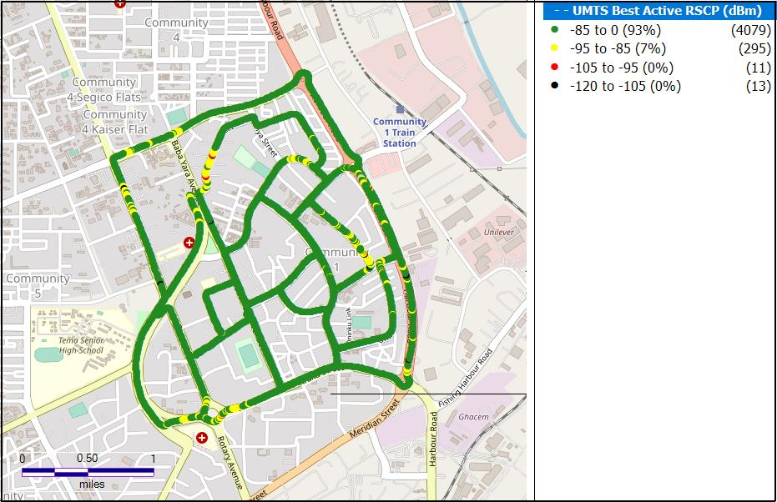Remarks:** Good network coverage in Tema. However, minor network improvement needed around Telesol and Access bank.

Figure 14. 3G Coverage Plot – Sowutuom

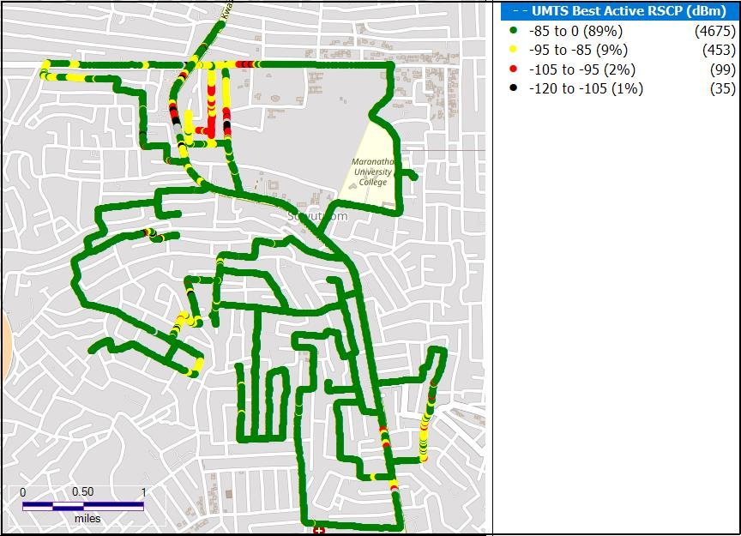

**Remarks:** Good Network Coverage in Sowutuom. Major network coverage improvement is required around the Envaserv research consult and Ryam gift hub.

## 1.2.4 RSCP Sampling Distribution

Figure 15. 3G Coverage Samples Plot

Remarks: GLO recorded highest count of RSCP samples in the range –85 ≤RSCP < –20 dBm however, major improvement is required in the 39.31% of samples that are out of Good coverage.

## CONCLUSION

* GLO has 3G coverage in twelve (12) of fourteen(14) District Capitals tested in the Greater Accra Region.
* GLO requires major 3G coverage improvement in all the district capitals tested with the exception of Tema and Kokomlele where minor improvements are needed.